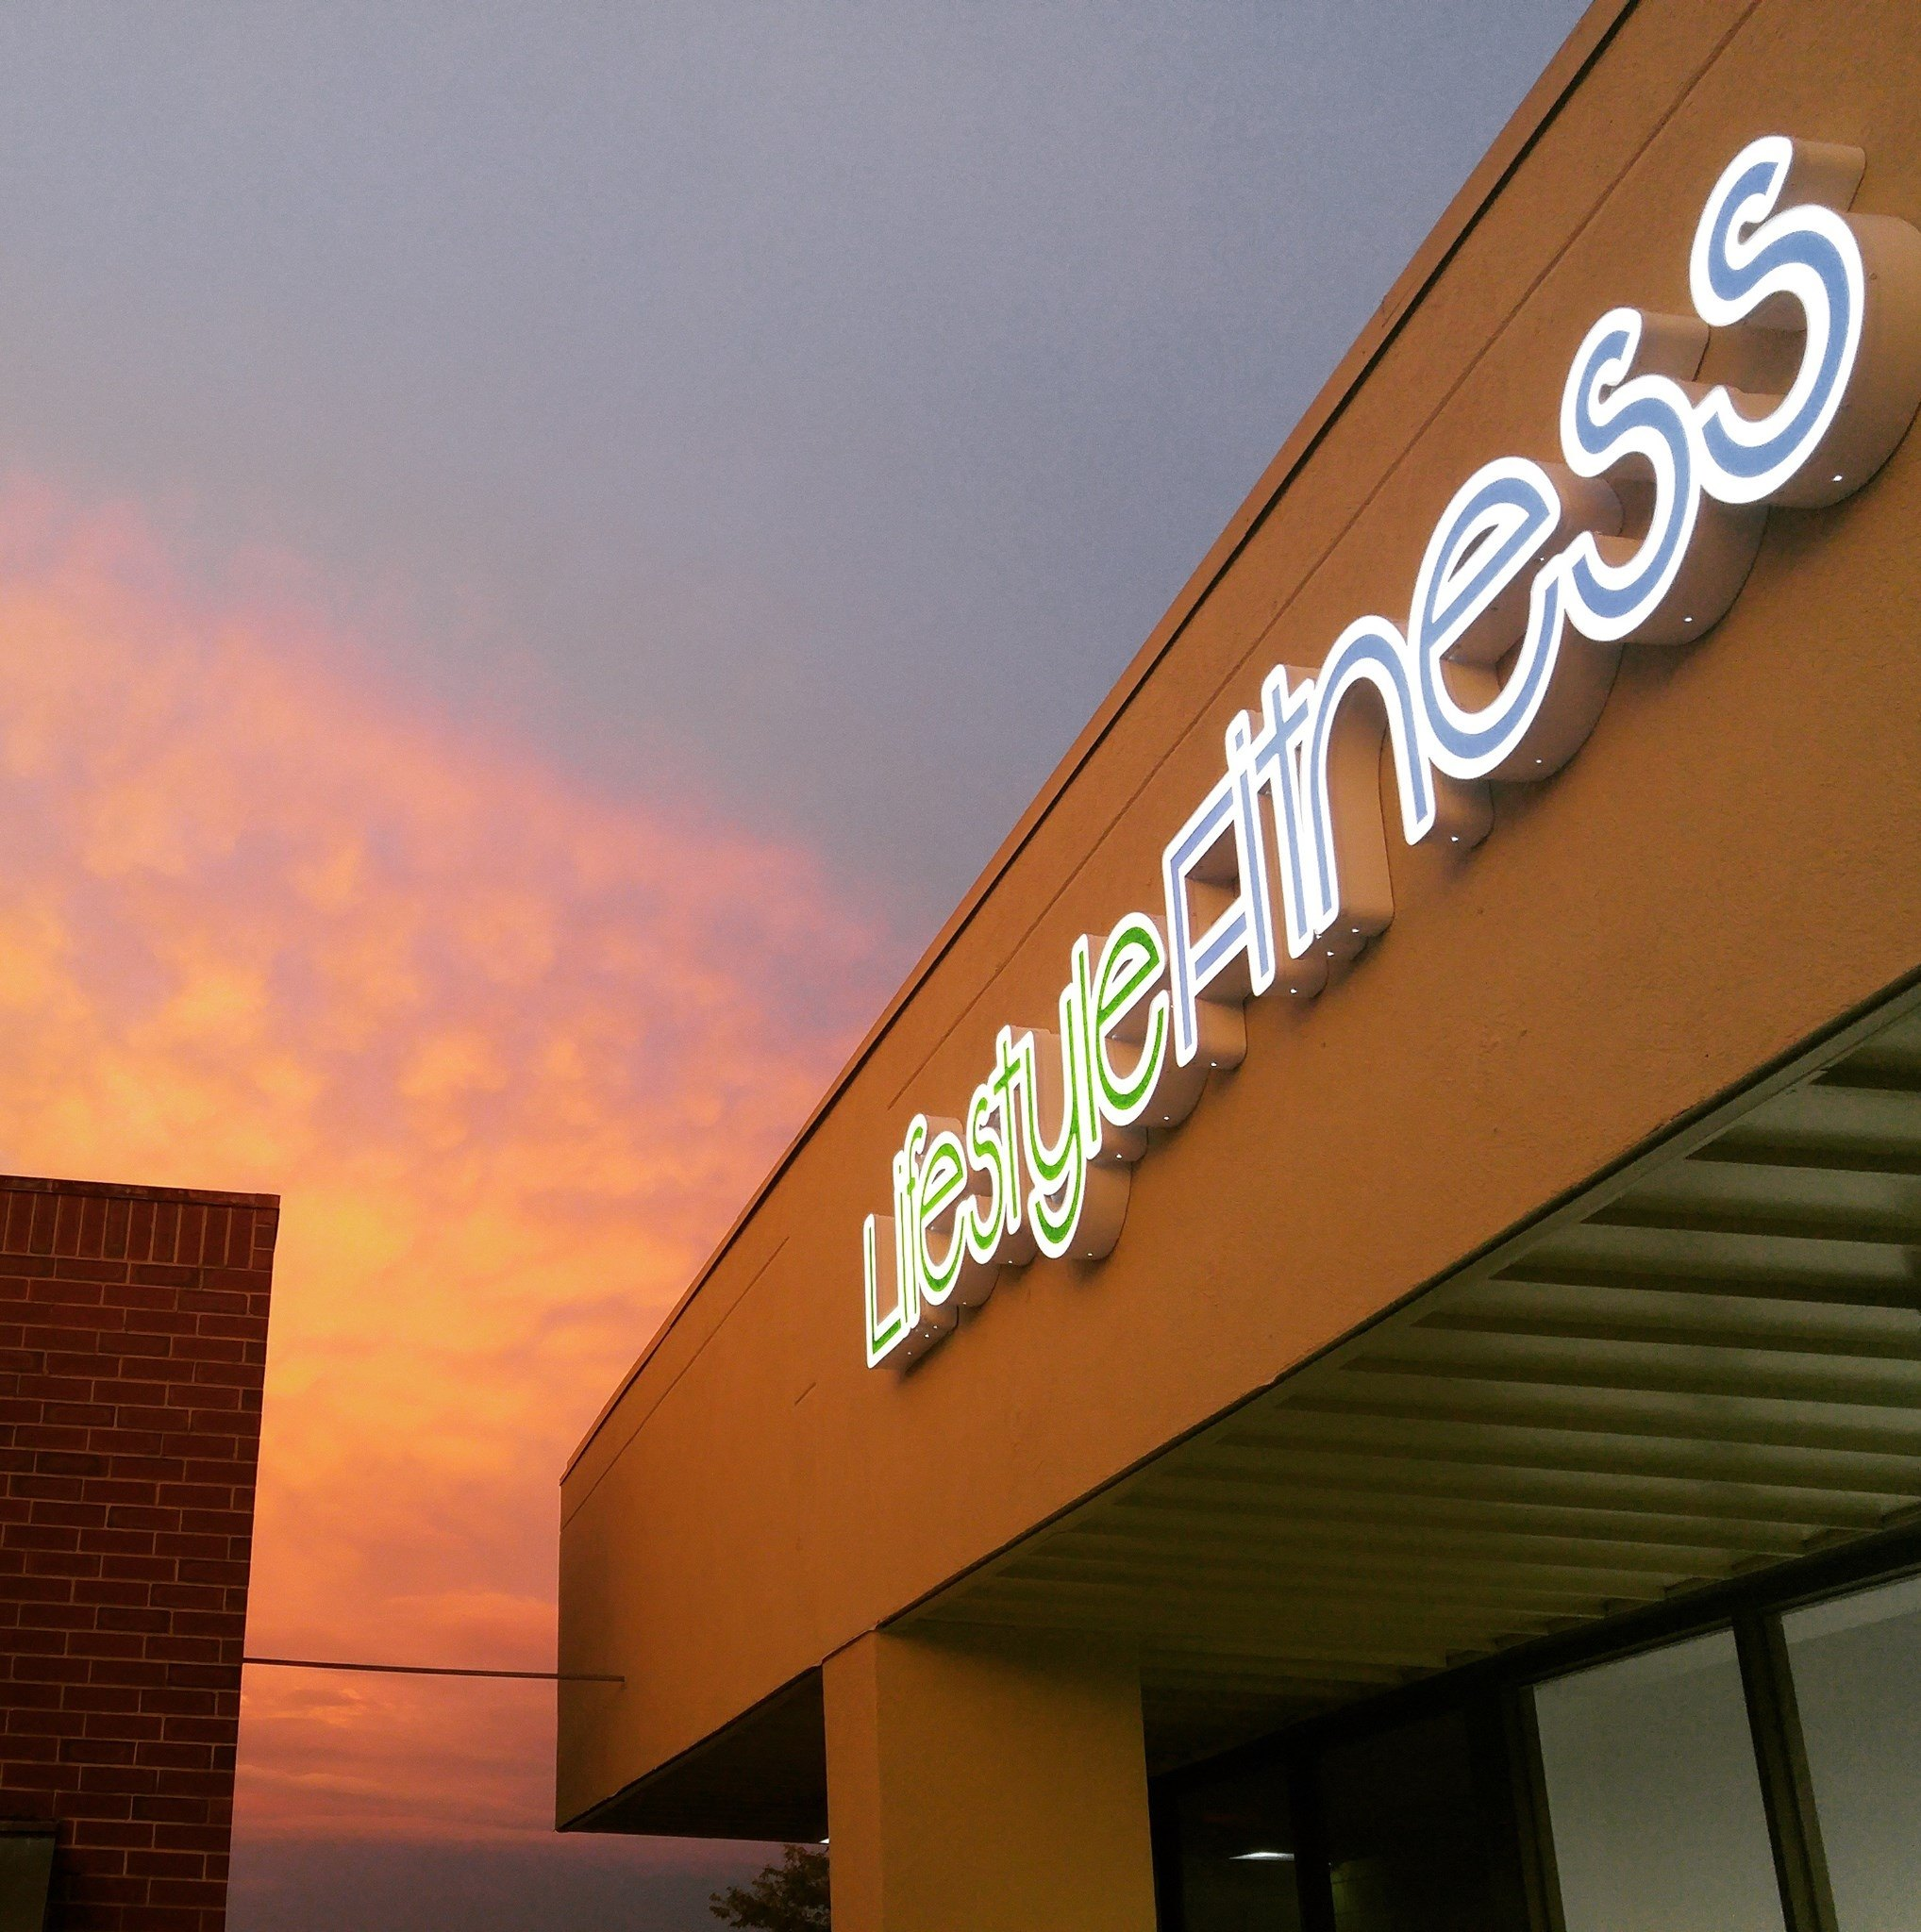  2018  Total Body transformation challenge  We Take the Guess-Work Out!  The daily workouts are each customized for a specific focus each day. While the workouts are done at your own pace, our trainers will always be there to guide, correct, instruct and PUSH! We will always be here to hold you accountable. | Customized, Guided, DAILY Workouts  ────  Nutritional Consulting & Assessments  ────  We Take the Guess-Work Out  ────  Like having a Personal Trainer w/o The Cost  ────  $100/Month *Min 3 Month  OR  $199 For 6 Weeks  Lifestyle Fitness  2075 E. Santa Fe.  Olathe, KS  913-558-0950  www.lifestylefitnesskc.org  Mon-Fri: 6-9 a.m., 11-2 p.m., 4-7 p.m.  Saturday: 8-3 p.m.

